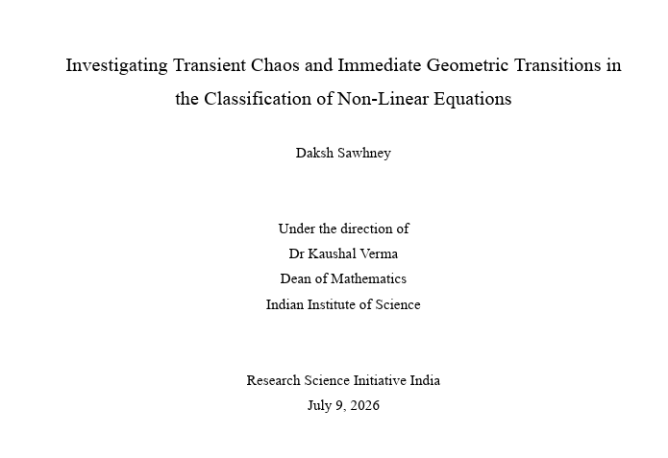
Overview of Research
This paper ξ = ((1 − 𝑠𝑔𝑛(𝐷) introduces | |)( 1 𝐾+1 | )) + ( 𝑠𝑔𝑛(𝐷) a structural | × (1 + 1 2(𝐷+𝐾) )) . classification coefficient Using a custom digital bifurcation diagram simulator, the study tracks and analyses the chaotic behaviours of multiple non-linear equations over continuous ranges of parameters. The simulator ran 1000 settling iterations followed by 500 recorded steps per value. For the logistic map rx(1-x) and rsin(x), smooth unimodal maps were classified under = ξ 0.5. It demonstrated continuous pitchfork branching routes to chaos that scale precisely according to the universal Feigenbaum constant of = 4.669. Smooth multimodal maps classified under δ 0 < ξ < 0.5 , for cubic and quintic equations like r(x5-x3+x), showcase overlapping wave-like geometric structures and sudden vertical attractor expansions triggered by interior crises. Piecewise linear maps were categorised under 1. 0 < ξ < 1.5 , for the linear tent map r(1-2|x-0.5|) and the absolute value map 1-r|x|, bypass the period-doubling cascade entirely, transitioning directly from a single stable fixed point into a solid chaotic wedge characterised by uniform point density and distinct unvisited lens-shaped regions. These quantitative findings establish that the classification coefficient functions as an accurate baseline for classifying non-linear chaotic dynamics based on the visual properties of the bifurcation diagrams.

